CSV 206 ASSIGNMENT 4

Name: K.Punith Sai

Roll No: K21XRA12

REG.NO:12115191

Q1)

Create an file “script.sh” and write script in the file , at end mention the location of file “script.log” output is to be saved.

Change the permission of file and run it. Make it to print output as well as error, so that both will be saved in the .log file.

Create an cronjob by “crontab -e” command.

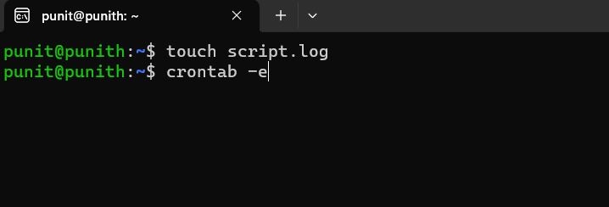

Make a cronjob to run for every 5mins and it is stored in the “script.log” file.

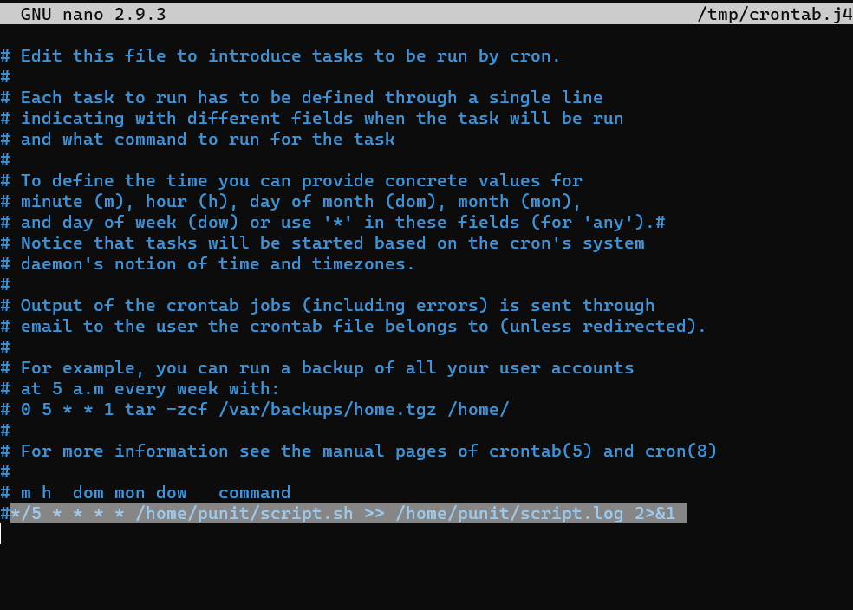

After executing the file , print the content of “script.log” file by cat command.

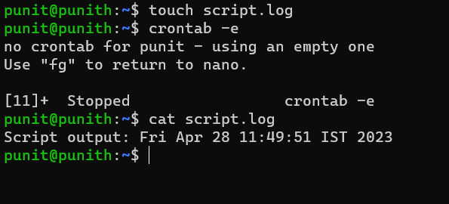

Q2)

Now, create an directory named “scripts” and create a file “lab.sh” in the folder.

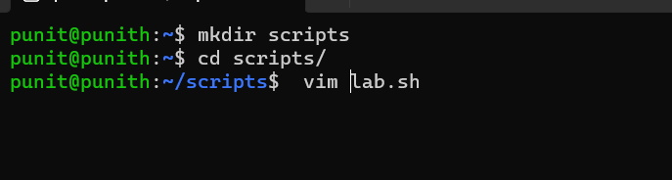

Write the script in the file for cleaning the directory for 30days.

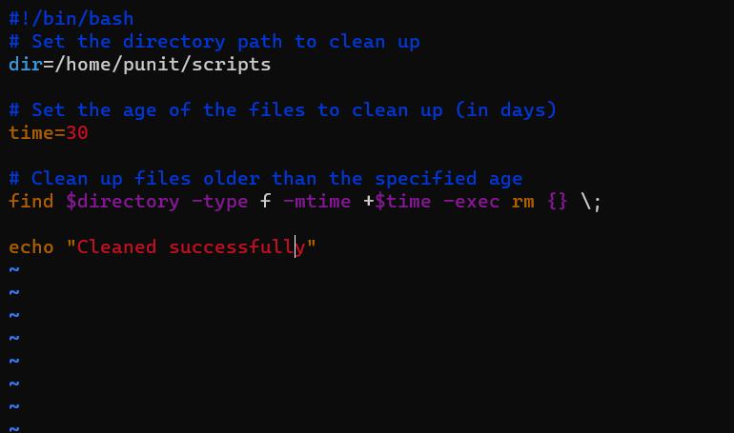

Execute the file.

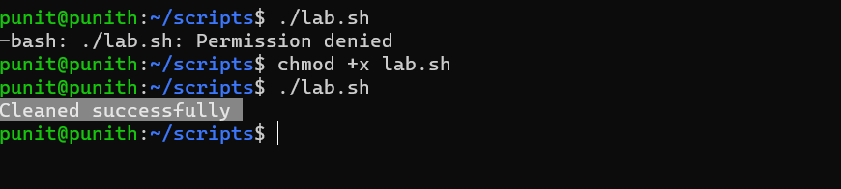

Make a cronjob for the file to run every midnight.

Q3)

Create a .sh file “cpu_ram.sh”.

Write the script for checking usage of CPU and RAM.

